Assignment 1

Submitted to:
Sir Mubashir UbaidUllah
Submitted by:
Muhammad Faizan
Registration no:
FA22-BSE-052
Course:
Visual Programming

“Department of Computer Science”
COMSATS University Islamabad,
“Vehari Campus”

Question # 1:
Event-Driven Programming vs Procedural Programming
Event-Driven Programming:
Event-driven programming is a programming paradigm where the program's execution depends on events like user actions (mouse clicks, key presses), sensor inputs, or messages from other programs. Instead of following a strict sequence, it responds whenever an event occurs.
Key Features:
- Event Handlers: Special functions that execute when an event happens.
- Event Listeners: Continuously monitor for specific events.
- Asynchronous Execution: The program doesn't wait for a task to finish before moving forward, making applications more responsive.
Examples:
- Clicking a "Submit" button triggers an event to send a form.
- Pressing "Ctrl + S" saves a document.
- A motion sensor detecting movement and triggering an alarm.
Procedural Programming:
Procedural programming is a step-by-step approach where code executes in a structured and sequential manner. Programs are divided into functions that follow a defined flow from start to end.
Key Features:
- Fixed Execution Order: The program runs line-by-line.
- Uses Functions: Code is divided into reusable functions.
- Predictable Output: Best for tasks that require strict control flow.
Conclusion:
Both paradigms have their strengths. Event-driven programming is ideal for applications requiring user interaction and real-time responsiveness, while procedural programming is better suited for structured, predictable tasks. Ethical software design means choosing the right approach based on user needs, performance, and security considerations.

Question # 2:
Pass by Value vs Pass by Reference
Pass by Value:
- In pass by value, a copy of the variable is passed to the method. Any changes inside the method do not affect the original variable.
- Pass by value is useful when you do not want a method to change the original variable.
Example:
using System;
class Program
{
static void ChangeValue(int num)
{
num = 10;
}

static void Main()
{
int myNumber = 5;
ChangeValue(myNumber);
Console.WriteLine(myNumber);
}
}

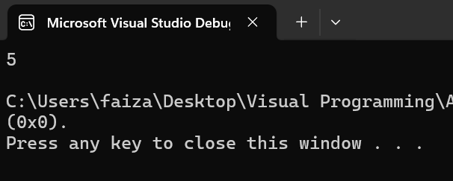Explanation:
- The variable myNumber is passed as a copy to the ChangeValue method.
- Inside the method, num is modified, but this change does not affect myNumber.
- So, the output remains 5, as the original value is not changed.

Pass by Reference:
- In pass by reference, the actual variable is passed to the method. Any change inside the method affects the original variable directly.
- Pass by reference (ref) is useful when you want a method to modify the original variable
Example:
using System;
class Program
{
static void ChangeValue(ref int num)
{
num = 10;
}
static void Main()
{
int myNumber = 5;
ChangeValue(ref myNumber);
Console.WriteLine(myNumber);
}
}
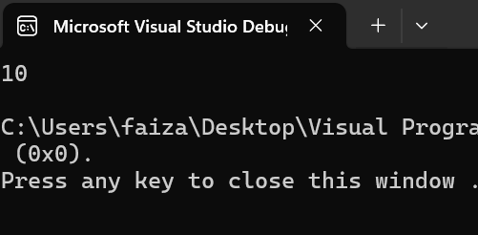Explanation:
- The ref keyword ensures that the actual variable is sent to the method.
- Inside the method, num directly refers to myNumber, so any change to num modifies myNumber.
- The output is 10, showing that the original value has changed.
Question # 3:
using System;
class Program
{
static void Main()
{
int age, classifier = 0;
Console.Write("Enter your age = ");
age = int.Parse(Console.ReadLine());
if (age >= 0 && age <= 10)
{
classifier = 1;
}
else if (age >= 11 && age <= 17)
{
classifier = 2;
}
else if (age >= 18 && age <= 40)
{
classifier = 3;
}
else if (age >= 41)
{
classifier = 4;
}
switch (classifier)
{
case 1:
Console.WriteLine("You are a child");
break;
case 2:
Console.WriteLine("You are a teenager");
break;
case 3:
Console.WriteLine("You are young");
break;
case 4:
Console.WriteLine("You are an adult");
break;
default:
Console.WriteLine("Invalid age entered.");
break;
}
}
}
